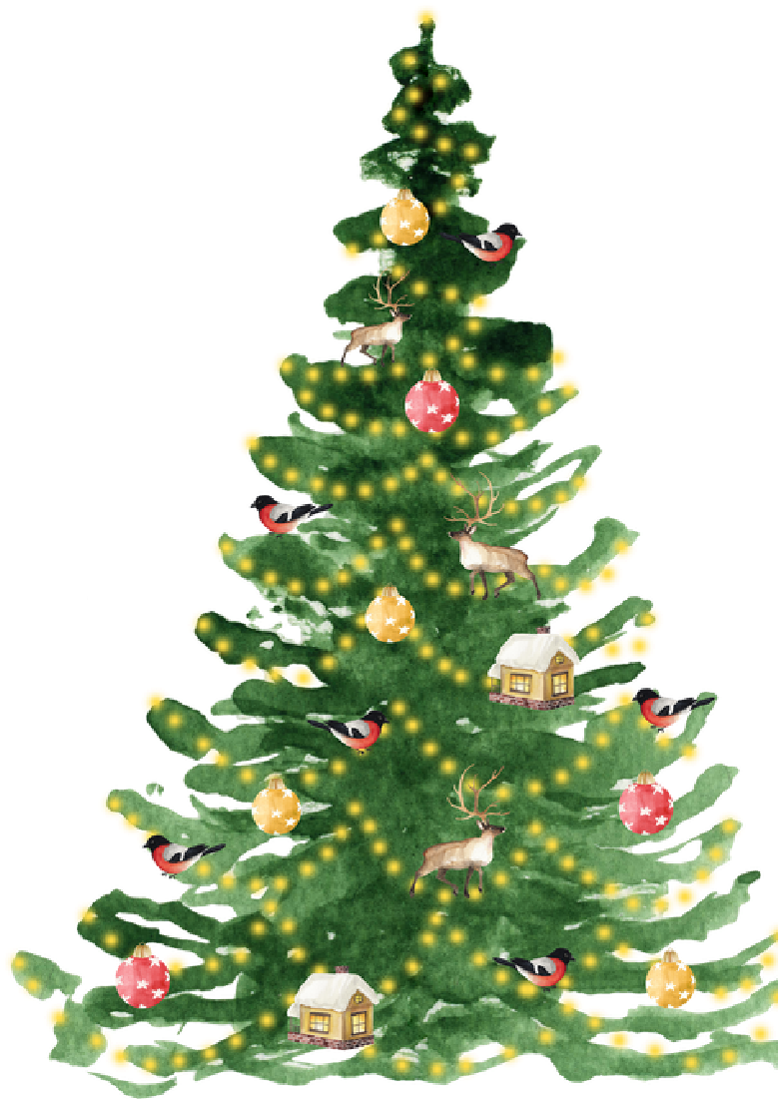

**CHRISTMAS & NEW YEAR SERVICE HOURS**

DECEMBER:

Friday 22nd - Open 8am-1pm. Closed from 1pm

Saturday 23rd & Sunday 24th - Closed

Monday 25th & Tuesday 26th - Closed

Wednesday 27th & Thursday 28th - Open

Friday 29th - Open 8am-1pm. Closed from 1pm

Saturday 30th & Sunday 31st - Closed

JANUARY:

Monday 1st - Closed

Tuesday 2nd - Open

NORMAL OFFICE HOURS RESUMED

Core opening hours: 8:00am-5:00pm

OPEN THROUGHOUT THE FESTIVE PERIOD:

: 0808 168 9111

/7 Supportline

24

Livechat:

[/](https://www.victimsupport.org.uk/help-and-support/get-help/support-near-you/live-chat/)

[victimsu](https://www.victimsupport.org.uk/help-and-support/get-help/support-near-you/live-chat/)

[p](https://www.victimsupport.org.uk/help-and-support/get-help/support-near-you/live-chat/)

[port.or](https://www.victimsupport.org.uk/help-and-support/get-help/support-near-you/live-chat/)

[g](https://www.victimsupport.org.uk/help-and-support/get-help/support-near-you/live-chat/)

[.uk/live-chat](https://www.victimsupport.org.uk/help-and-support/get-help/support-near-you/live-chat/)

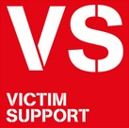

0300 303 3706

nsvictimcare@victimsupport.org.uk

nsvictimcare.org